**SINGLE LEVEL INHERITANCE FOR BANK**

**import java.util.Scanner;**

**class Bank {**

**int inputDeposit() {**

**Scanner sc = new Scanner(System.in);**

**System.out.print("Enter the Deposit amount: ");**

**int da = sc.nextInt();**

**return da;**

**}**

**int inputWithdraw() {**

**Scanner sc = new Scanner(System.in);**

**System.out.print("Enter the Withdraw amount: ");**

**int wa = sc.nextInt();**

**return wa;**

**}**

**int inputTransfer() {**

**Scanner sc = new Scanner(System.in);**

**System.out.print("Enter the Transfer amount: ");**

**int ta = sc.nextInt();**

**return ta;**

**}**

**}**

**class Transaction extends Bank {**

**int deposit(int ta, int da) {**

**return ta + da;**

**}**

**int withdraw(int ta, int wa) {**

**return ta - wa;**

**}**

**int transfer(int ta, int tra) {**

**return ta - tra;**

**}**

**}**

**public class Main {**

**public static void main(String[] args) {**

**int total = 1000;**

**int[] accountNumbers = {1001, 1002, 1011, 1012};**

**Arrays.sort(accountNumbers);**

**Scanner sc = new Scanner(System.in);**

**Transaction t = new Transaction();**

**int choice;**

**while (true) {**

**System.out.println("\nBank balance: " + total);**

**System.out.println("Enter choice: Deposit = '1', Withdraw = '2', Transfer = '3', Exit = '4'");**

**choice = sc.nextInt();**

**if (choice == 1) {**

**int depAmou = t.inputDeposit();**

**total = t.deposit(total, depAmou);**

**System.out.println("Before Deposit: " + (total - depAmou));**

**System.out.println("After Deposit: " + total);**

**} else if (choice == 2) {**

**int witAmou = t.inputWithdraw();**

**if (witAmou > total) {**

**System.out.println("Insufficient amount");**

**} else {**

**total = t.withdraw(total, witAmou);**

**System.out.println("Before Withdraw: " + (total + witAmou));**

**System.out.println("After Withdraw: " + total);**

**}**

**} else if (choice == 3) {**

**System.out.print("Enter account number to transfer to: ");**

**int accNum = sc.nextInt();**

**if (Arrays.binarySearch(accountNumbers, accNum) >= 0) {**

**int traAmou = t.inputTransfer();**

**if (traAmou > total) {**

**System.out.println("Insufficient amount");**

**} else {**

**total = t.transfer(total, traAmou);**

**System.out.println("Before Transfer: " + (total + traAmou));**

**System.out.println("After Transfer: " + total);**

**}**

**} else {**

**System.out.println("Invalid account number");**

**}**

**} else if (choice == 4) {**

**System.out.println("Exiting");**

**break;**

**} else {**

**System.out.println("Invalid choice");**

**}**

**}**

**}**

**}**

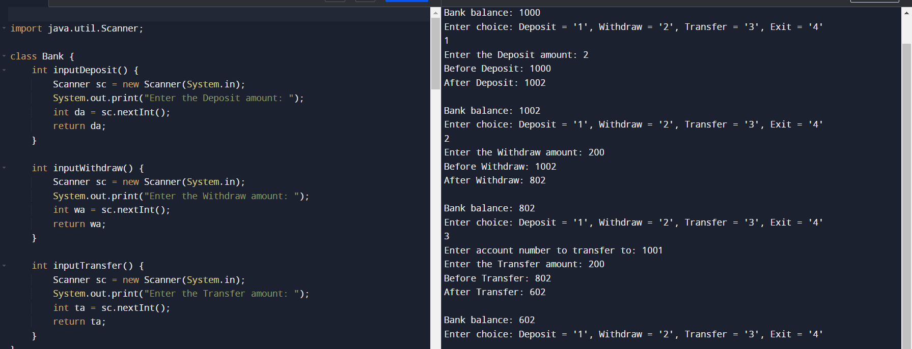

**HIERARCHICAL INHERITANCE FOR BANK**

**import java.util.Arrays;**

**import java.util.Scanner;**

**class Bank {**

**int inputDeposit() {**

**Scanner sc = new Scanner(System.in);**

**System.out.print("Enter the Deposit amount: ");**

**int da = sc.nextInt();**

**return da;**

**}**

**int inputWithdraw() {**

**Scanner sc = new Scanner(System.in);**

**System.out.print("Enter the Withdraw amount: ");**

**int wa = sc.nextInt();**

**return wa;**

**}**

**int inputTransfer() {**

**Scanner sc = new Scanner(System.in);**

**System.out.print("Enter the Transfer amount: ");**

**int ta = sc.nextInt();**

**return ta;**

**}**

**}**

**class Transaction extends Bank {**

**int deposit(int ta, int da) {**

**return ta + da;**

**}**

**int withdraw(int ta, int wa) {**

**return ta - wa;**

**}**

**int transfer(int ta, int tra) {**

**return ta - tra;**

**}**

**}**

**class Deposit extends Transaction {**

**void performDeposit(int total) {**

**int depAmou = inputDeposit();**

**total = deposit(total, depAmou);**

**System.out.println("Before Deposit: " + (total - depAmou));**

**System.out.println("After Deposit: " + total);**

**}**

**}**

**class Withdraw extends Transaction {**

**void performWithdraw(int total) {**

**int witAmou = inputWithdraw();**

**if (witAmou > total) {**

**System.out.println("Insufficient amount");**

**} else {**

**total = withdraw(total, witAmou);**

**System.out.println("Before Withdraw: " + (total + witAmou));**

**System.out.println("After Withdraw: " + total);**

**}**

**}**

**}**

**class Transfer extends Transaction {**

**void performTransfer(int total, int[] accountNumbers) {**

**Scanner sc = new Scanner(System.in);**

**System.out.print("Enter account number to transfer to: ");**

**int accNum = sc.nextInt();**

**if (Arrays.binarySearch(accountNumbers, accNum) >= 0) {**

**int traAmou = inputTransfer();**

**if (traAmou > total) {**

**System.out.println("Insufficient amount");**

**} else {**

**total = transfer(total, traAmou);**

**System.out.println("Before Transfer: " + (total + traAmou));**

**System.out.println("After Transfer: " + total);**

**}**

**} else {**

**System.out.println("Invalid account number");**

**}**

**}**

**}**

**class ShowBalance extends Transaction {**

**void displayBalance(int total) {**

**System.out.println("\nBank balance: " + total);**

**}**

**}**

**public class Main {**

**public static void main(String[] args) {**

**int total = 1000;**

**int[] accountNumbers = {1001, 1002, 1011, 1012};**

**Arrays.sort(accountNumbers);**

**Scanner sc = new Scanner(System.in);**

**Deposit deposit = new Deposit();**

**Withdraw withdraw = new Withdraw();**

**Transfer transfer = new Transfer();**

**ShowBalance showBalance = new ShowBalance();**

**int choice;**

**while (true) {**

**showBalance.displayBalance(total);**

**System.out.println("Enter choice: Deposit = '1', Withdraw = '2', Transfer = '3', Exit = '4'");**

**choice = sc.nextInt();**

**if (choice == 1) {**

**deposit.performDeposit(total);**

**} else if (choice == 2) {**

**withdraw.performWithdraw(total);**

**} else if (choice == 3) {**

**transfer.performTransfer(total, accountNumbers);**

**} else if (choice == 4) {**

**System.out.println("Exiting");**

**break;**

**} else {**

**System.out.println("Invalid choice");**

**}**

**}**

**}**

**}**

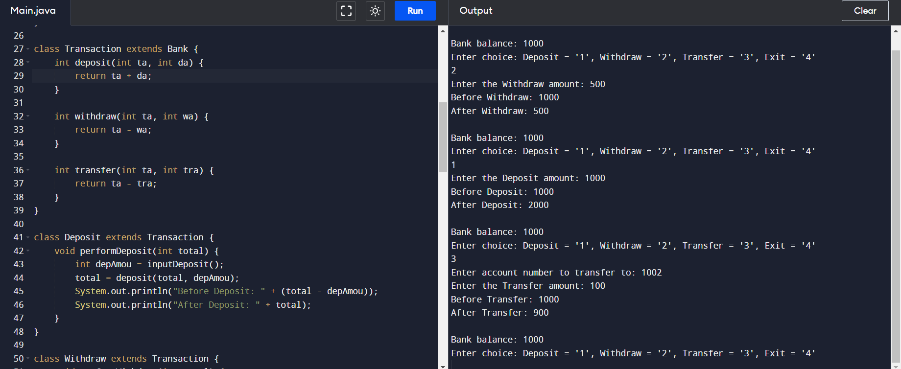

**MULTILEVEL INHERITANCE FOR BANK**

**import java.util.Scanner;**

**class Account {**

**protected int balance;**

**public Account(int initialBalance) {**

**if (initialBalance < 2000) {**

**System.out.println("Minimum balance should be 2000. Setting balance to 2000.");**

**this.balance = 2000;**

**} else {**

**this.balance = initialBalance;**

**}**

**}**

**public void displayBalance() {**

**System.out.println("Current balance: " + balance);**

**}**

**}**

**class Transaction extends Account {**

**public Transaction(int initialBalance) {**

**super(initialBalance);**

**}**

**public void deposit(int amount) {**

**balance += amount;**

**System.out.println("Deposited: " + amount);**

**}**

**public void withdraw(int amount) {**

**if (balance - amount < 0) {**

**System.out.println("Insufficient funds.");**

**} else {**

**balance -= amount;**

**System.out.println("Withdrawn: " + amount);**

**}**

**}**

**public void transfer(int amount) {**

**if (balance - amount < 0) {**

**System.out.println("Insufficient funds.");**

**} else {**

**balance -= amount;**

**System.out.println("Transferred: " + amount);**

**}**

**}**

**}**

**class Transfer extends Transaction {**

**public Transfer(int initialBalance) {**

**super(initialBalance);**

**}**

**public void performTransfer() {**

**Scanner scanner = new Scanner(System.in);**

**System.out.print("Enter amount to transfer: ");**

**int amount = scanner.nextInt();**

**transfer(amount);**

**}**

**}**

**class Withdraw extends Transaction {**

**public Withdraw(int initialBalance) {**

**super(initialBalance);**

**}**

**public void performWithdraw() {**

**Scanner scanner = new Scanner(System.in);**

**System.out.print("Enter amount to withdraw: ");**

**int amount = scanner.nextInt();**

**withdraw(amount);**

**}**

**}**

**public class Main {**

**public static void main(String[] args) {**

**int initialBalance = 2000;**

**Transfer transferAccount = new Transfer(initialBalance);**

**Withdraw withdrawAccount = new Withdraw(initialBalance);**

**Scanner scanner = new Scanner(System.in);**

**int choice;**

**while (true) {**

**transferAccount.displayBalance();**

**System.out.println("Enter choice: Transfer = 1, Withdraw = 2, Exit = 3");**

**choice = scanner.nextInt();**

**switch (choice) {**

**case 1:**

**transferAccount.performTransfer();**

**break;**

**case 2:**

**withdrawAccount.performWithdraw();**

**break;**

**case 3:**

**System.out.println("Exiting.");**

**return;**

**default:**

**System.out.println("Invalid choice.");**

**}**

**}**

**}**

**}**

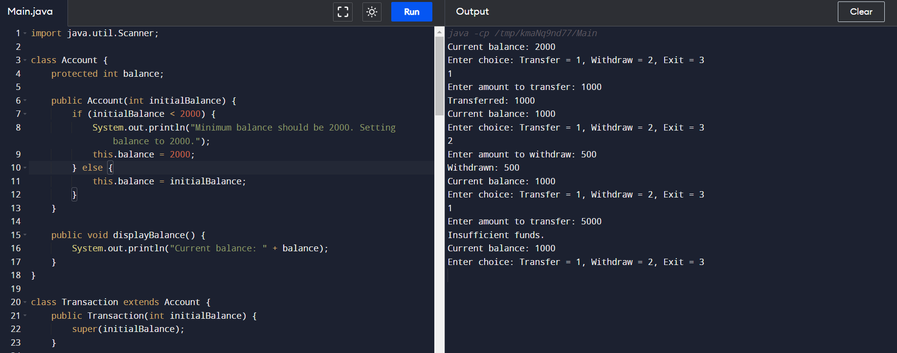

**INTERFACE – MARKS**

**import java.util.Scanner;**

**interface TenthStandard {**

**void display10thDetails();**

**}**

**interface TwelfthStandard {**

**void display12thDetails();**

**}**

**class Student {**

**String name;**

**int regNo;**

**Student(String name, int regNo) {**

**this.name = name;**

**this.regNo = regNo;**

**}**

**}**

**class TenthStandardStudent implements TenthStandard {**

**Student student;**

**int[] marks;**

**TenthStandardStudent(String name, int regNo, int[] marks) {**

**this.student = new Student(name, regNo);**

**this.marks = marks;**

**}**

**public void display10thDetails() {**

**System.out.println("Name: " + student.name);**

**System.out.println("Registration No: " + student.regNo);**

**System.out.println("10th Standard Marks:");**

**for (int i = 0; i < marks.length; i++) {**

**System.out.println("Subject " + (i + 1) + ": " + marks[i]);**

**}**

**}**

**}**

**class TwelfthStandardStudent implements TwelfthStandard {**

**Student student;**

**int[] marks;**

**TwelfthStandardStudent(String name, int regNo, int[] marks) {**

**this.student = new Student(name, regNo);**

**this.marks = marks;**

**}**

**public void display12thDetails() {**

**System.out.println("Name: " + student.name);**

**System.out.println("Registration No: " + student.regNo);**

**System.out.println("12th Standard Marks:");**

**for (int i = 0; i < marks.length; i++) {**

**System.out.println("Subject " + (i + 1) + ": " + marks[i]);**

**}**

**}**

**}**

**public class Main {**

**public static void main(String[] args) {**

**Scanner scanner = new Scanner(System.in);**

**System.out.print("Enter name for 10th Standard Student: ");**

**String name10th = scanner.nextLine();**

**System.out.print("Enter registration number for 10th Standard Student: ");**

**int regNo10th = scanner.nextInt();**

**System.out.print("Enter number of subjects for 10th Standard Student: ");**

**int numSubjects10th = scanner.nextInt();**

**int[] marks10th = new int[numSubjects10th];**

**for (int i = 0; i < numSubjects10th; i++) {**

**System.out.print("Enter marks for subject " + (i + 1) + ": ");**

**marks10th[i] = scanner.nextInt();**

**}**

**TenthStandardStudent student10th = new TenthStandardStudent(name10th, regNo10th, marks10th);**

**scanner.nextLine();**

**System.out.print("Enter name for 12th Standard Student: ");**

**String name12th = scanner.nextLine();**

**System.out.print("Enter registration number for 12th Standard Student: ");**

**int regNo12th = scanner.nextInt();**

**System.out.print("Enter number of subjects for 12th Standard Student: ");**

**int numSubjects12th = scanner.nextInt();**

**int[] marks12th = new int[numSubjects12th];**

**for (int i = 0; i < numSubjects12th; i++) {**

**System.out.print("Enter marks for subject " + (i + 1) + ": ");**

**marks12th[i] = scanner.nextInt();**

**}**

**TwelfthStandardStudent student12th = new TwelfthStandardStudent(name12th, regNo12th, marks12th);**

**student10th.display10thDetails();**

**System.out.println();**

**student12th.display12thDetails();**

**scanner.close();**

**}**

**}**

